Logistic Regression

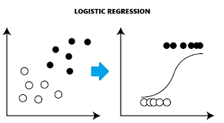

Y=mx+c

M=slope

X=data points

C=intercept

h0(x)=theta(0)+theta(1)X

=B(0)+B(1)X

Y=wTx+theta